Lecture No. 239

8.6 Architectural Views

Software architecture defines the high level structure of the software by putting together a
number of architectural elements in an organized fashion. These elements are chosen to
satisfy the functional as well as non-functional requirements of the system. Perry and
Wolfe proposed the following formula for software architecture:

Software architecture = {Elements, Forms, Rationale}

That is, a software architecture is a set of elements which have a certain form. These
elements are further divided into three categories. These are: data elements, processing
elements, and connecting elements. The data elements contain the information that is
used and transformed in the system; the processing elements process the data elements
and specify the transformation functions, and connecting elements connect different
pieces of architecture together. These can themselves be data or processing elements.

This formula was modified by Boehm as follows:

Software architecture = {Elements, Forms, Rationale/Constraints}

Krutchen proposed that the software architecture model should be composed of multiple
views as a software architecture deals with abstraction, with decomposition and
composition, with style and esthetics as well as requirements from different stake holders.
His architectural model is known as Krutchen’s 4+1 architectural view model. As
evident, this model proposes the development of 5 main views namely the logical view,
the process view, the physical view, the development view, and the use case view. The
logical view is the object model of the design, the process view captures the concurrency
and synchronization aspects of the design, the physical view documents the mapping(s)
of the software onto the hardware and reflects its distributed aspect, the development
view describes the static organization of the software in its development environment,
and the use case view uses selected use cases or scenarios to validate that the architecture
supports the required functionality.

This model is shown in the following diagram.
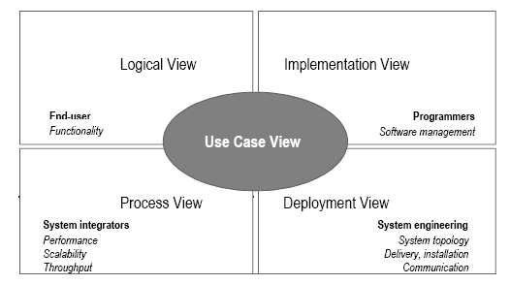
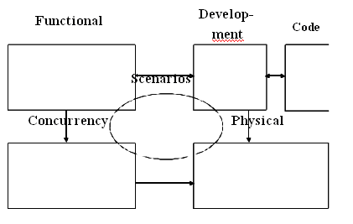

Clement’s modified version of Krutchen’s 4+1 Architectural View Model

This model has been slightly modified by Clements et. al. and is shown in the above
diagram.
In this model, the architecture is again prepared and analyzed from 5 different
perspectives. The 4 main views are Functional View, the Concurrency View, the Physical
View, and the Development View. Code view in not present in the original Krutchen
model and is basically an extension of the development view.

The Functional View comprises of various different functions provided by the system,
key system abstraction, and the domain elements. It connects different dependencies and
data flows into a single view. This view can be used by the domain engineers, product-
line engineers, as well as the end users of the system. It can be used for understanding the
functionality provided by the system, modifiability of the system, reusability, tool
support, and allocation of work.

The Development View documents the different files and directories in the system and
users of this view include the development and the configuration management staff as
well as the project managers. The major uses of this view include maintenance, testing,
configuration management, and version control.

The components of the Code View include classes, objects, procedures, functions,
subsystems, layers, and modules. It documents the calling as well as the containing
hierarchy of different components of the system. Its primary users are the programmers
and designers of the system. The primary intent of developing this view is to use it for
maintenance and portability.

Concurrency View intends to document different parallel processes and threads in the
system. Its main focus is on event synchronization and parallel data flows. It is used
primarily by integrators, performance engineers, and testers. The main purpose of
building this view is to identify ways and means to improve performance by highlighting
possible opportunities for parallelism.

The Physical View depicts the physical organization of this system and how this system
will be physically deployed. This includes different processors, sensors, and storage
devices used by the system. This view connects various network elements and
communication devices. The primary users of this system include hardware and system
engineers. The view is developed with an intention to document and analyze system
delivery and installation mechanism. The view is also used in understanding and
analyzing issues pertaining to system performance, availability, scalability, and security.

Finally, there are Scenarios. Scenarios are basically use cases which describe the
sequences of responsibilities and change cases which are changes to the system. As stated
earlier, the first objective of developing a system is to fulfill the functional requirements
setout for the system. These functional requirements are written in the form of use cases.
Therefore, scenarios are used to understand and validate the system. Their secondary
purpose is to communicate the design to the other users of the system. Scenarios tie all
the view together into an integrated system. They are also used to understand the
dynamic behavior of the system and understand the limits of design.

This is summarized in the following table:

View

Components

Users

Rationale

Functional
functions,
key
domain engineers,
functionality,

View
system abstractions,
domain elements
product-line
designers, end users
modifiability,
lines/reusability,
product
tool

Code View

classes,
procedures,
functions,

objects,

programmers,
designers, reusers
support, work allocation
modifiability/maintainabi
lity, portability,
subsetability

Development
View
subsystems, layers,
modules
files, directories

managers,
programmers,
configuration
managers

managers, programmers,
configuration managers

Physical
View
CPUs,
storage
sensors,
hardware engineers,
system engineers
system delivery and
installation, performance,
availability, scalability,
security

Concurrency
View
processes, threads
performance
engineers,
integrators, testers
performance, availability

_____________________________________________________________________
© Copyright Virtual University of Pakistan

CS504-Software Engineering – I VU

What Are Views Used For?

Views are an engineering tool to help achieve desired system qualities. Each view
provides an engineering handle on certain quality attributes. In some systems, distinct
views collapse into one (e.g., the concurrency and physical views may be the same for
small systems.). Views are also used as documentation vehicle for current development
and future development. Users of views include both managers and customers. For these
reasons views must be annotated to support analysis. This annotation can be achieved
with the help of scenarios and design rationale.

Structures can also be used to document how the current system was developed and how
future development should occur. This information is needed by managers and
customers.

Although one often thinks about a system’s structure in terms of functionality, there are
other system properties in addition to functionality (such as physical distribution, process
communication, and synchronization) that must be reasoned about at an architectural
level. Each structure provides a method for reasoning about some of the relevant quality
attributes. The uses structure, for instance, must be engineered (not merely recorded) to
build a system that can easily be extended or contracted. The calls structure is engineered
to reduce bottlenecks. The module structure is engineered to produce modifiable systems,
and so on. Each structure provides a different view into the system and a different
leverage point for design to achieve desired qualities in the system.

Hierarchical Views

Every view is potentially hierarchical, e.g. functional view could contain sub-functions.
Similarly development view contains directories which contain files. Code view would
have modules and systems that contain sub-modules and sub-systems respectively.
Concurrency view contains processes that are further subdivided into threads. Finally,
physical view clusters contain computers which contain processors.

Architectural views are related to each other in complicated ways. One has to choose the
views that are useful to the system being built and to the achievement of qualities that are
important for that particular application. The architectural views should be hierarchical
(where needed) and should contain enough annotated information to support desired
analyses.

Architectural styles

The architectural model of a system may conform to a generic architectural model or
style. An awareness of these styles can simplify the problem of defining system
architectures. However, most large systems are heterogeneous and do not follow a single
architectural style.

_____________________________________________________________________
© Copyright Virtual University of Pakistan
CS504-Software Engineering – I VU

Each style describes a system category that encompasses:

(1) a set of components (e.g., a database, computational modules) that perform a function
required by a system,
(2) a set of connectors that enable “communication, coordination and cooperation”
among components,
(3) constraints that define how components can be integrated to form the system, and

semantic models that enable a designer to understand the overall properties of a system
by analyzing the known properties of its constituent parts.

